Task No. 03: Write a Program to print your Profile using C#.
Solution:
using System;

namespace Profile
{
class Program
{
static void Main(string[] args)
{
Console.WriteLine("My Profile");
Console.WriteLine(" -My name is Abdullah Sadiq.\n -My Father name is Muhammad Sadiq.\n -I am 17 year old.\n -I have done Fsc from Bahria College(NORE-1).\n -I am a student of Software Engineering at Bahria University(Karachi Campus).\n -My Hobby is Photography. I do it because I like it. ");
}
}
}
Output:
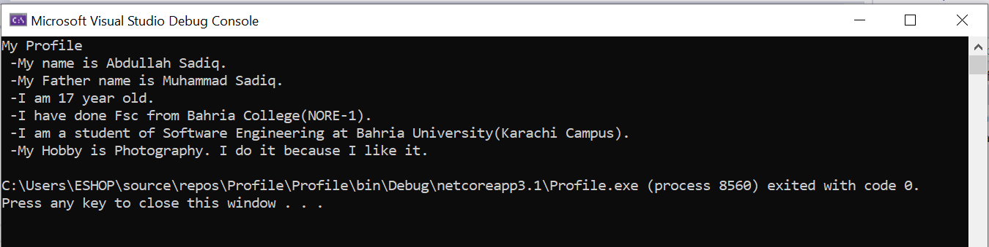
5

